**Guide to Importing Altium PCBs into Ansys HFSS and Simulating S-parameter (8/4/21)**

**Aidan Dougherty**

This guide uses Altium 21 and Ansys EM20.2. Be sure to have HFSS installed.

**Importing Altium PCBs into Ansys**

First, navigate to your PCB in Altium and select file >> export >> add exporter. Go to the “Purchased” tab at the top of the screen. Scroll down to Software Extensions and download Ansys EDB exporter. Once the download has finished, restart Altium.

Again navigate to your PCB and select file >> export >> Ansys EDB. You MUST save this to the same folder as your Altium project or it will not import correctly. Once we have imported to Ansys, you can move all of the Ansys files. Make sure your passives and ICs use a common designator letter (e.g. R, C, L, U) and fill out the Ansys export options.

At this stage it is a good idea to record all values of passive components as component values are not maintained when exporting to Ansys. A BOM is very useful here.

Open Ansys EDT and choose file >> import >> EDB. Navigate to the folder you saved the EDB in and select the file called “edb.def”. You should now see your PCB in Ansys. It should look something like this: Chart

Make sure to change component values to their intended values. Double check that your layer stackup is correct under layout >> layers.

**Setting up and Running a Simulation of S-parameter**

Every simulation in HFSS needs an excitation source. The first step is creating an Ansys port and assigning it to the port we want to measure the S-parameter of. You can repeat this process if you want to measure s-parameter between 2 different ports. Choose draw >> port >> create circuit port. Zoom in on the circuit element you are using as a circuit port. While hovering over the pads make sure you see a lightning-bolt symbol (this make take some zoom adjustment) and then click while hovering over the lightning-bolt to create the Ansys port.

Next choose HFSS 3D Layout >> Port Excitations. Configure the excitation properties.

Hit OK. Then navigate to the Simulation tab. Click Validate to make sure your setup meets all the simulation requirements. Choose HFSS>>auto. Configure your desired frequency range and other settings. Note that simulation takes a long time, so only use as many points as you need.

Under the Simulation tab, click analyze. Ansys will begin performing a frequency sweep and you can check the progress in the Progress panel. Make sure to close any memory-hungry applications like Chrome/Altium at this point.

Note: If you are not using a personal license, ensure that:

1. You have Enterprise/Pro license enabled in Ansys

Go to Desktop tab >> General Options >> Desktop Configuration >> Use Pro/Premium etc. license

1. Telnet Communication features are enabled

Windows search >> “Turn windows features on/off” >> Ensure Telnet is checked

Once the sim has finished running, to view results go to results tab >> standard report >> 2D and configure your desired output variables and measured port.

Hit New Report to view results.

You can now simulate Altium PCBs in HFSS.

**DEFINING IDEAL RLC COMPONENTS FOR SIMULATION**

In some cases, you will want to place an ideal capacitance/inductance/resistance to simulate properties of IC pins or ports etc. In the layout, simply right-click >> boundary >> create circuit element. Then click the two points where you want to place the terminals of your circuit element. Next double click on the placed element, enable any combination of R/L/C and define their values.

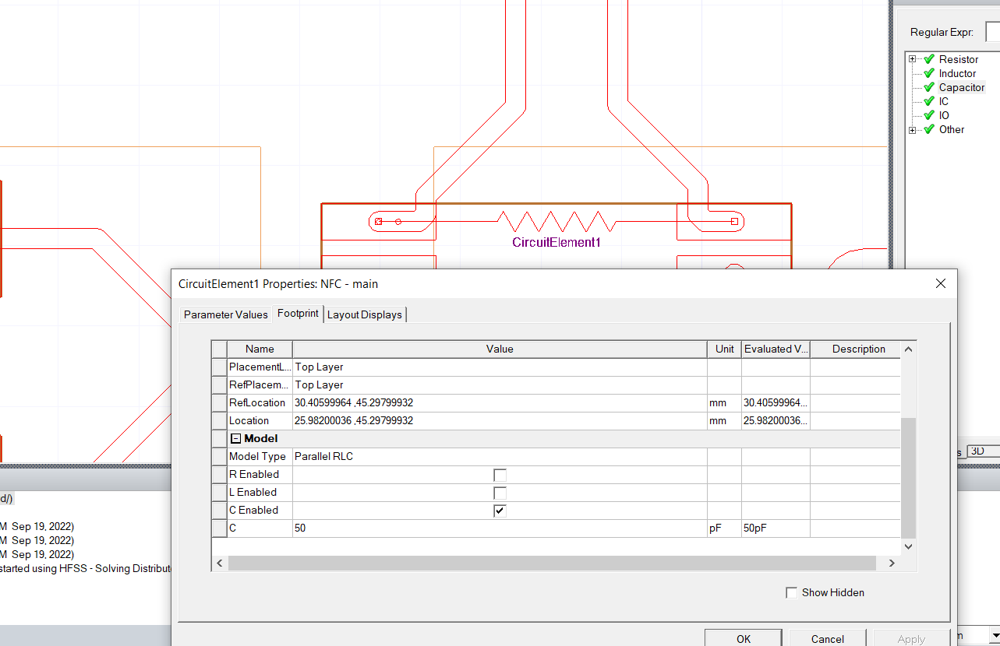

**VERY IMPORTANT**

In order to open previously created projects using this method, make sure to change the .edb folder that is created to .aedb. For example, your project files may look something like this:

In order to open the aedt file, you will need to change PCB4Res.edb to PCB4Res.aedb.

If you do not do this, you will run into an EDB file read configuration error when trying to open the project.